**Project 0501-13_Readme**

**Project Name: Optimus Solutions**

We have used Tableau to display the required outputs as stated in our mission objectives. The following steps highlight how to navigate through the Tableau frontend.

1. Download the application file.
2. Open the application in Tableau.
3. Input the required password of the database.

Password: lumos

1. This is how the dashboard would appear -

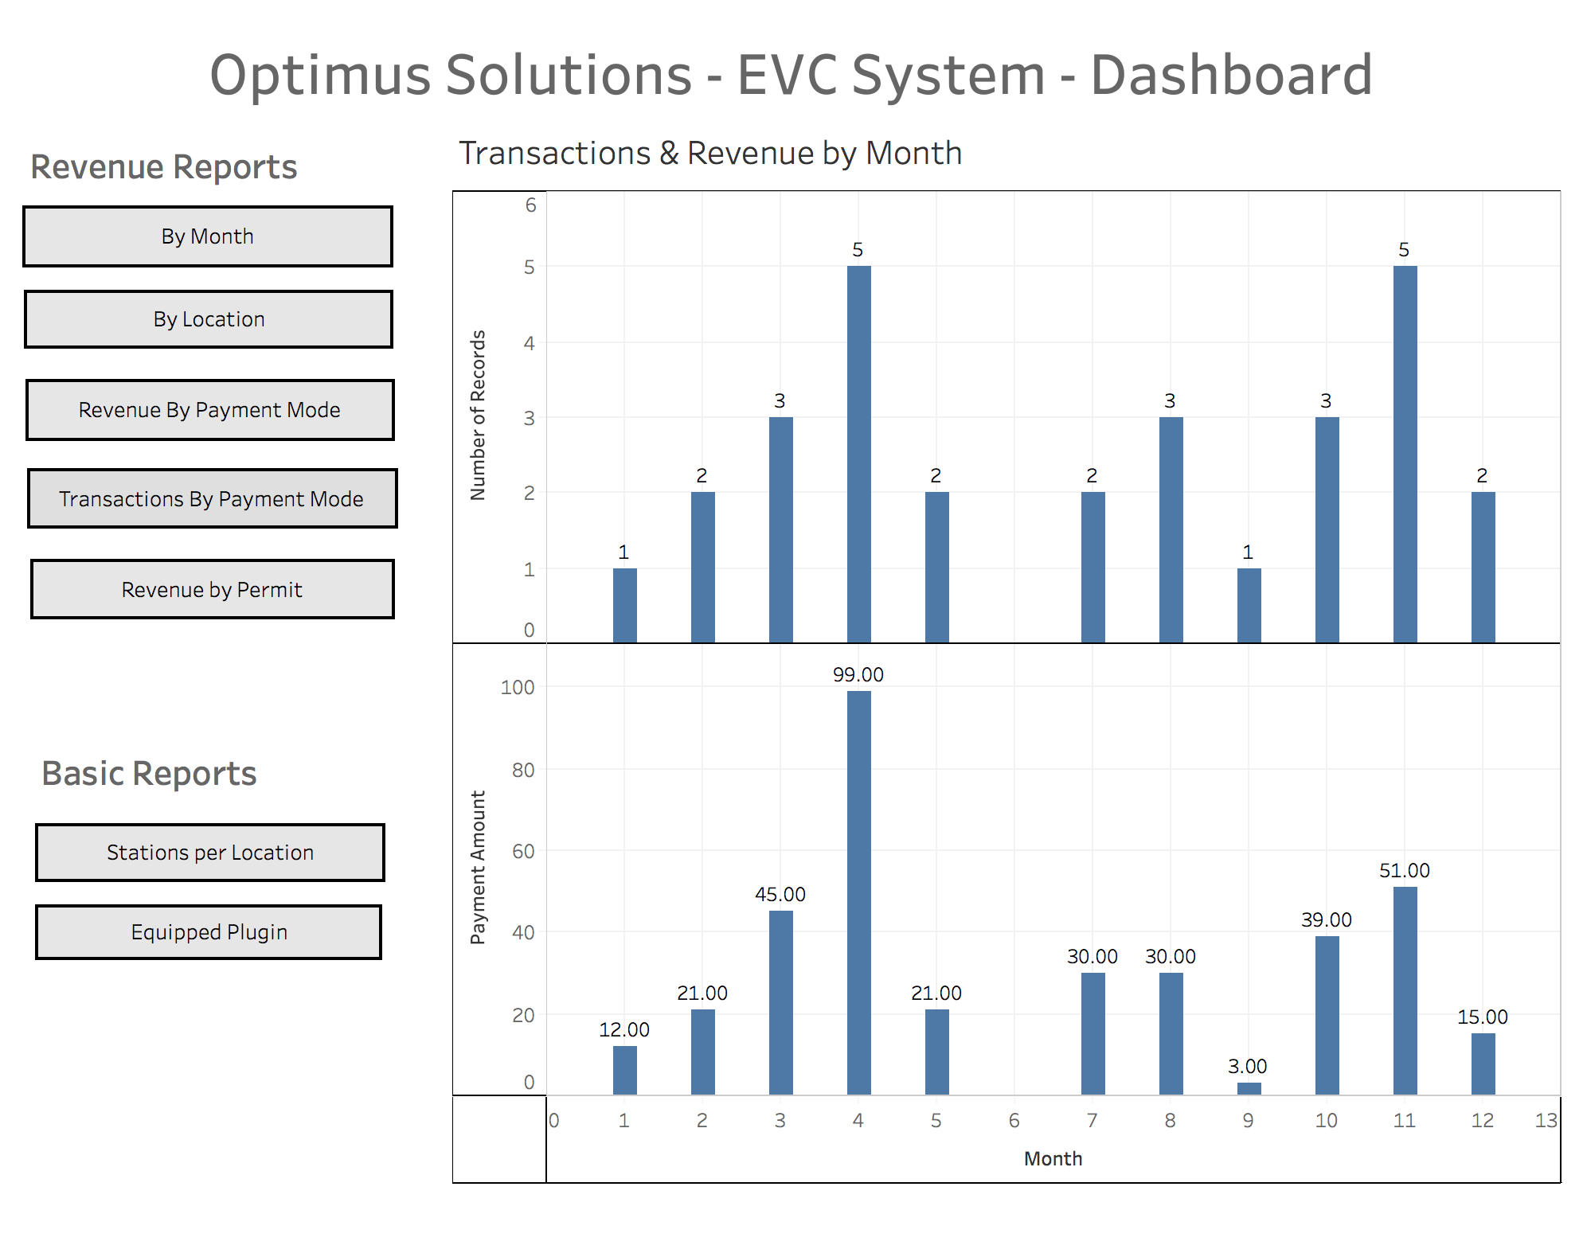

1. To track total number of transactions and revenue per month -



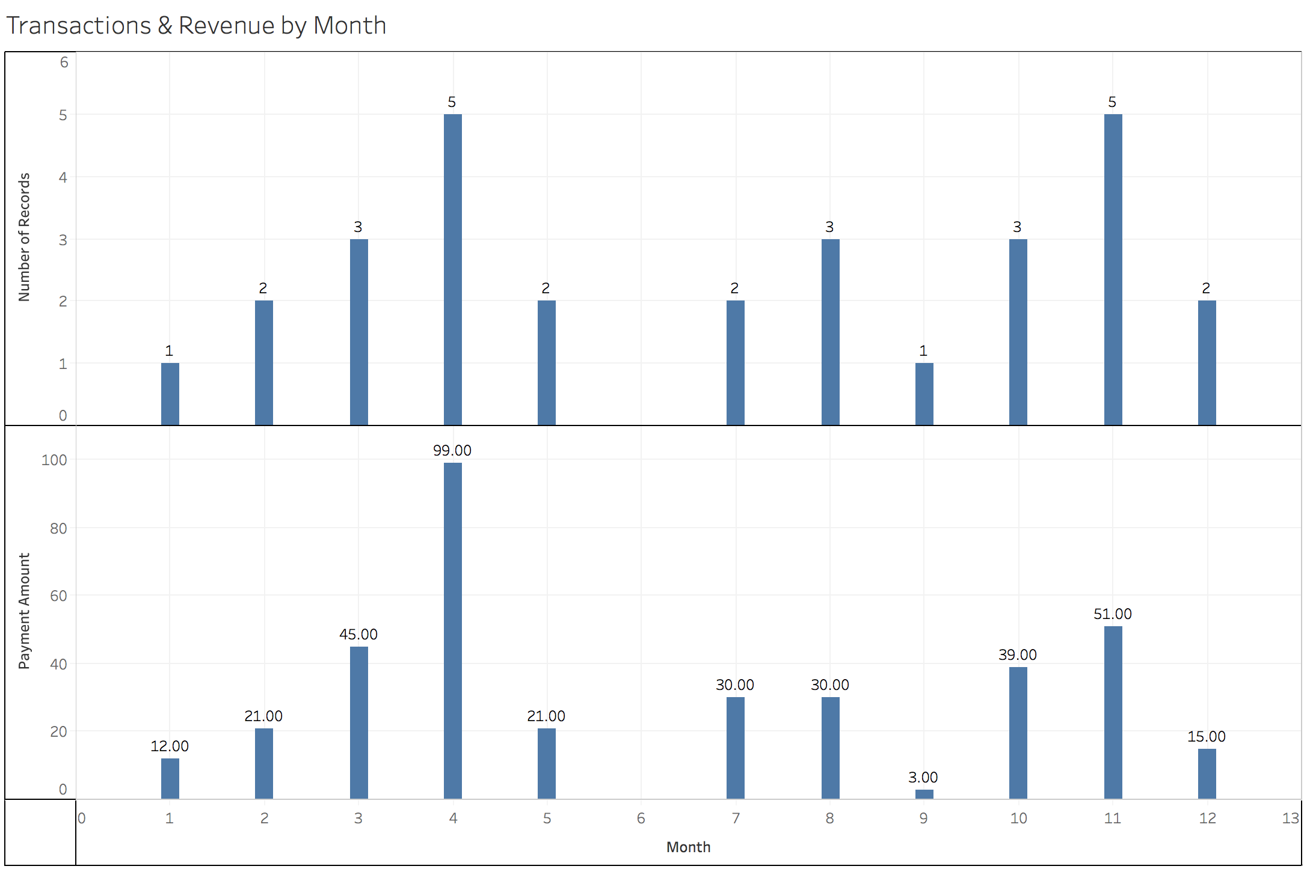

1. To track the total number of transactions at each location and the revenue generated from each -



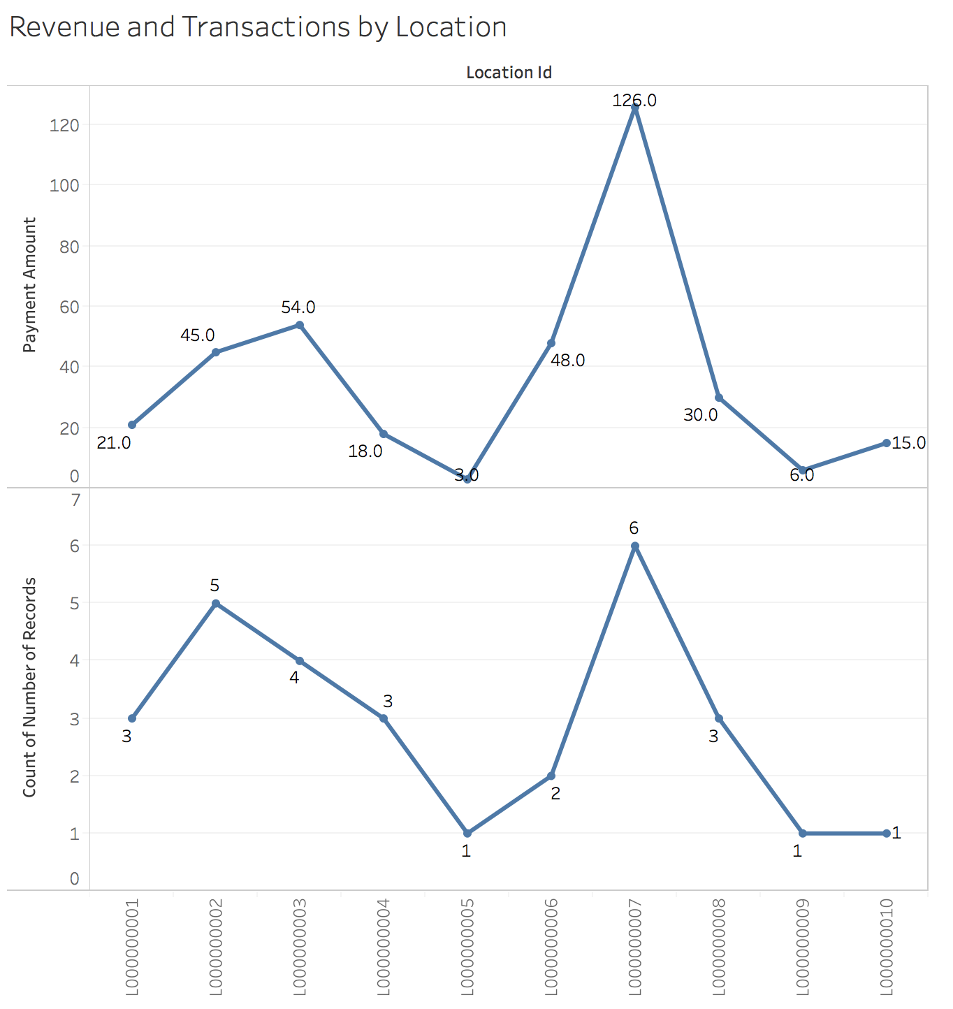

1. To check how often a particular payment mode is used by users and the revenue by each mode -



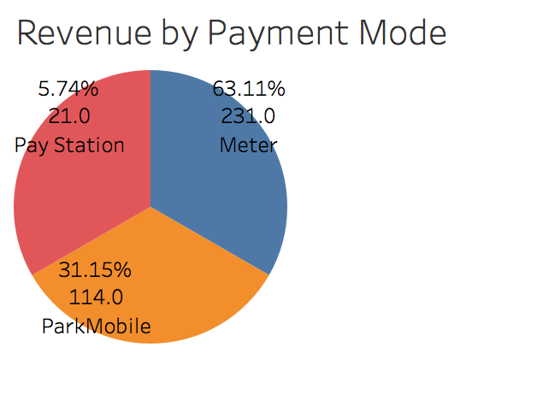

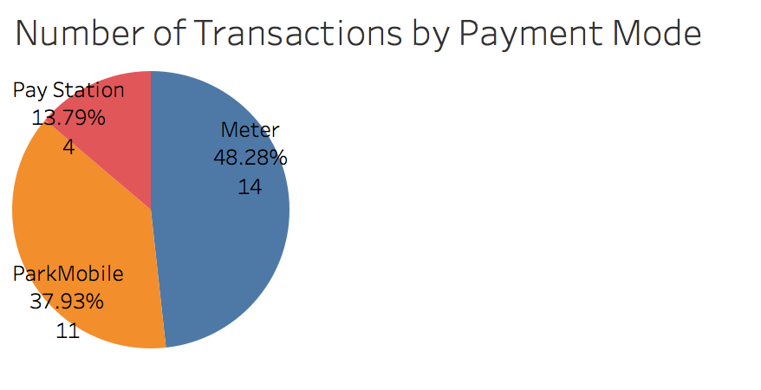

1. To check how much revenue is generated by drivers with and without a permit -



